WELCOME TO THE FIRST CALL APP
In-App Instructions

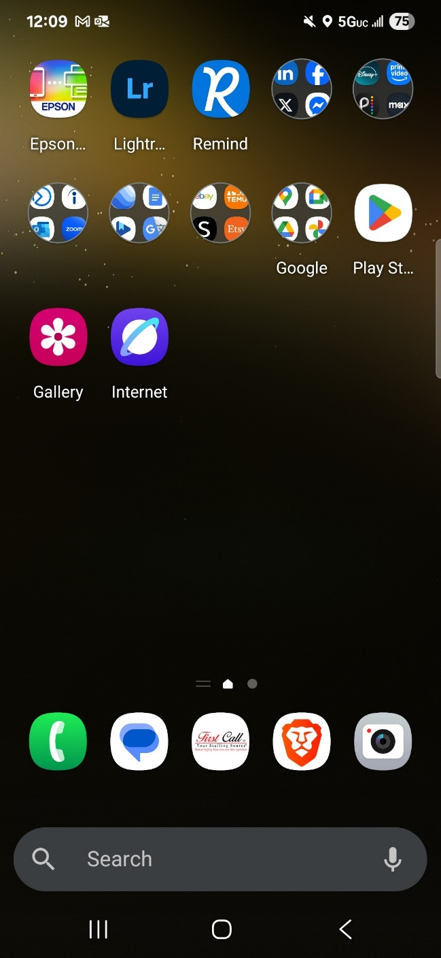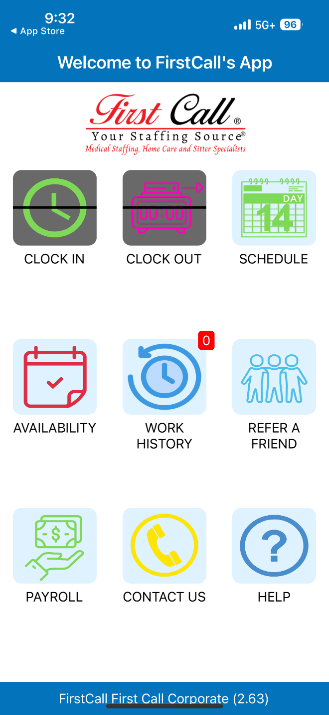

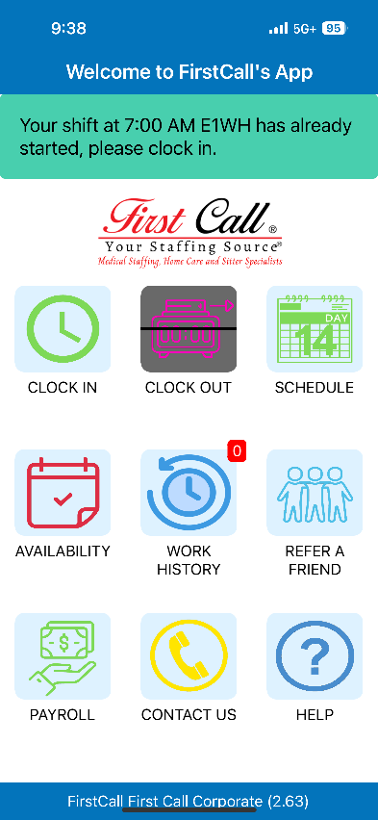
Clocking In:
- Click on the “Clock In” button when you arrive at your scheduled shift.
- Confirm your clock in time.
- Confirm your lunch break time.
- Add your sub-client and/or room number (if applicable – Sitter shifts).
- Click the applicable checkbox if you acted as a Charge Nurse or would like Daily Pay.
- Add any applicable comments or notes.
- Click the Clock In button again.
- Confirm your clock in time by selecting Yes on the pop-up.
- A pop-up requesting GPS access will appear. Click Allow.
- You should receive another pop-up confirming that you have now clocked in. Click OK.

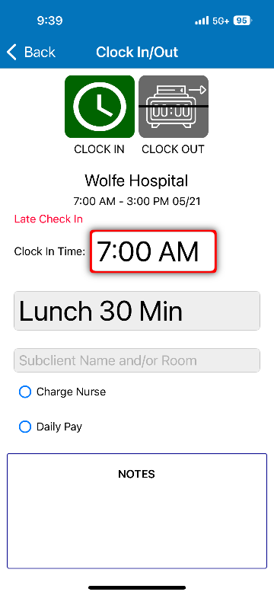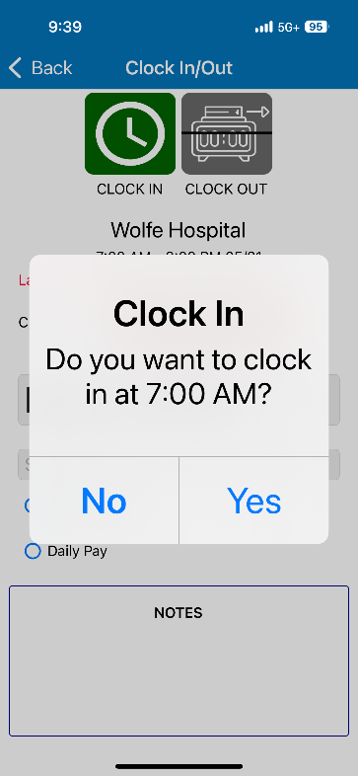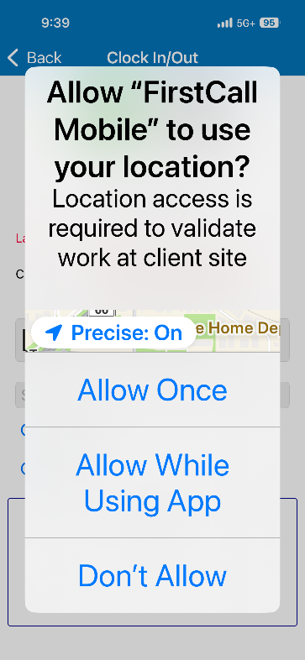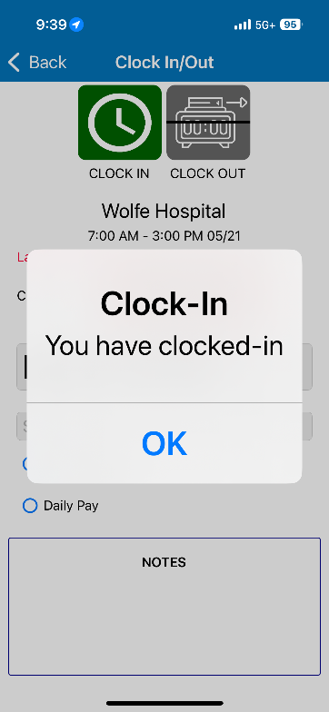
2
1

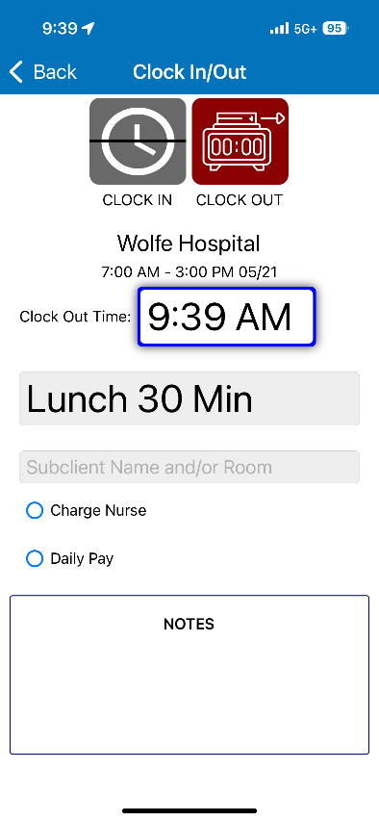
Clocking Out:
- Click the Clock Out button when you are ready to leave your shift.
- Confirm your clock-out time.
- Confirm your lunch break time.
- Add your sub-client and/or room number (if applicable – Sitter shifts).
- Click the applicable checkbox if you acted as a Charge Nurse or would like Daily Pay.
- Add any applicable comments or notes.
- Click the Clock Out button again.
- Confirm your Clock Out time by selecting OK on the pop-up.
- On the following screen, select “Digitally Sign” to sign your timesheet.
- Read the pop-up and click OK.
- Digitally sign your timesheet using your finger or stylus pen.
- Click Confirm.
- Read the confirmation pop-up and click OK.
- Hand your phone to the Charge Nurse on staff at your assignment and have them digitally sign as well. They will need to click Confirm.
- They will receive a pop-up to read and click OK.
- You should receive a pop-up confirmation that you have now successfully submitted your timesheet.

2
1
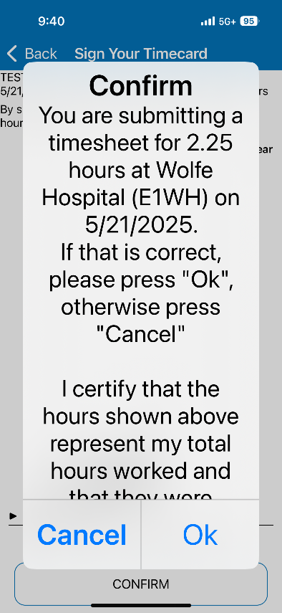
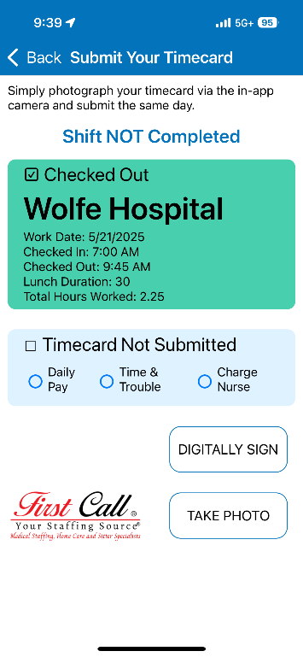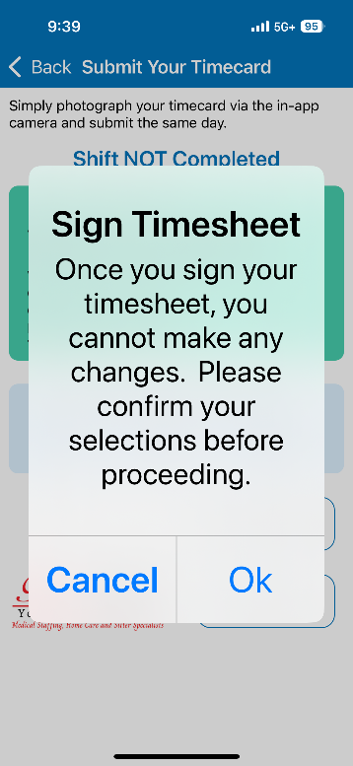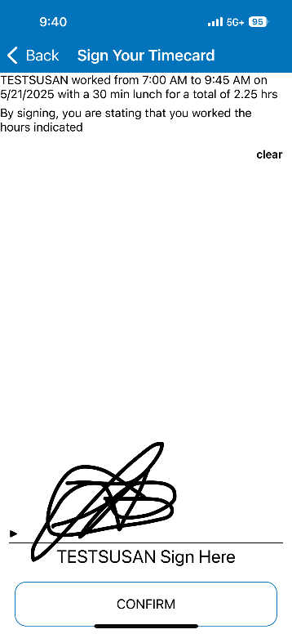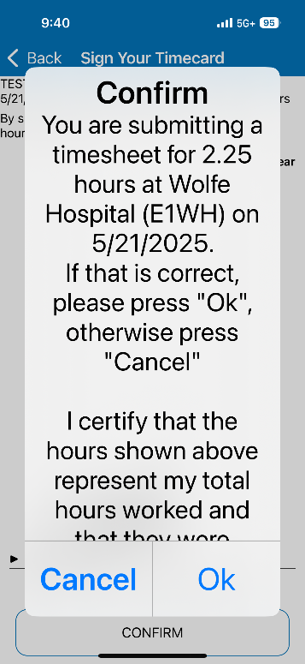
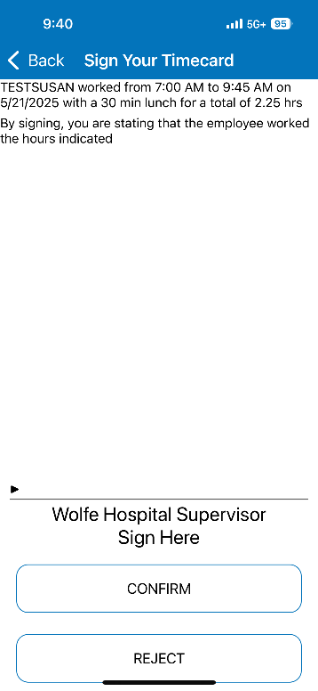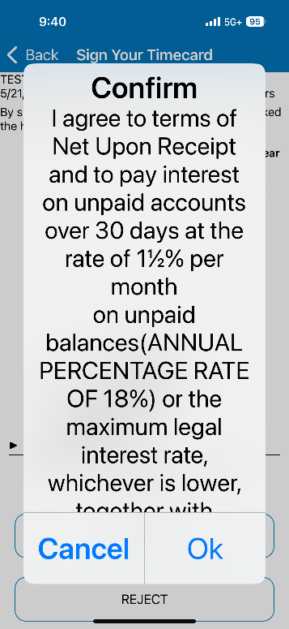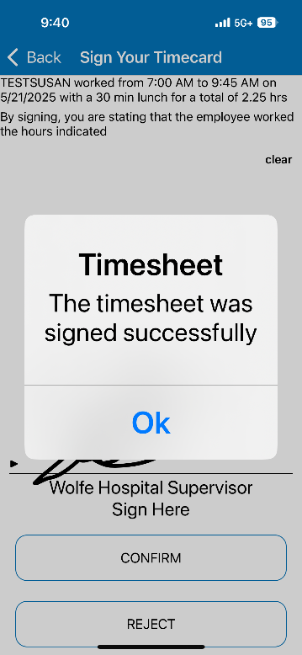

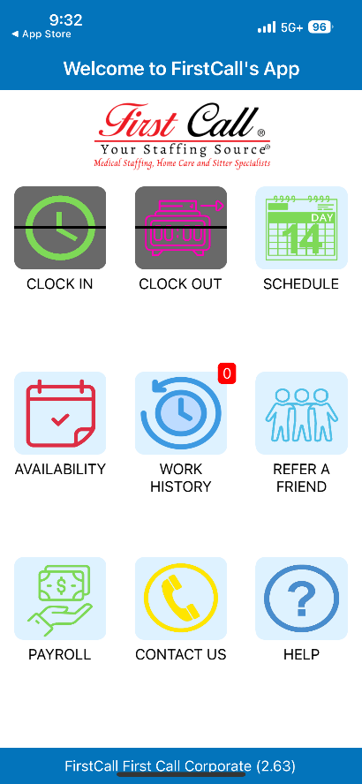
Viewing your Schedule:
- Click the Schedule button.
- Any assignments that you are scheduled for will show up in the calendar, represented by a colored dot.
- Click on the day you would like to view, and the assignment will pop up below the calendar.
- If you still need to submit a Timesheet for that assignment, you will be prompted to complete the Timesheet.
- To view a completed timesheet, click on the Timesheet button below the calendar. Scroll down to see the digital copy.

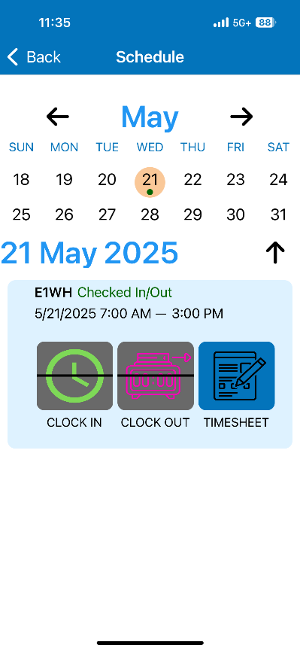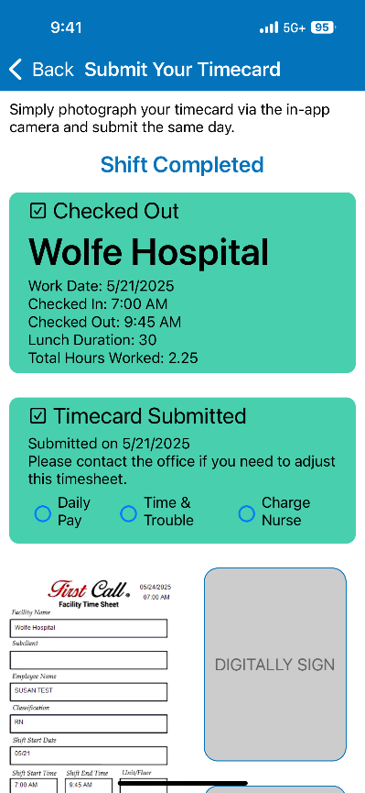

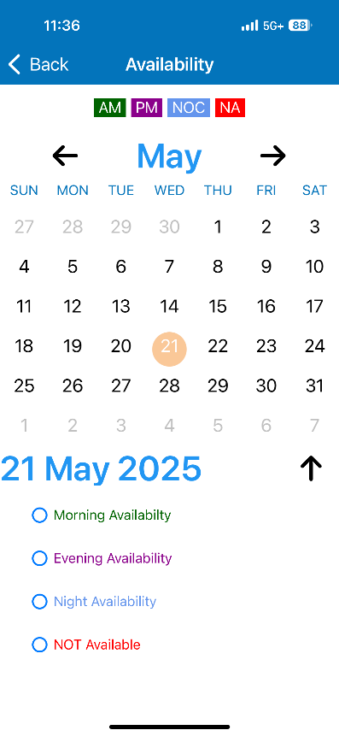
Submitting Availability:
- Click on the Availability button.
- Select a day you would like to be considered available/not available for work and select one of the options below the calendar: Morning, Evening, or Night Availability, or Not Available.
- Your Availability will automatically save.
- You can back out of the Availability section by clicking the back arrow at the top left corner to get back to the home screen.

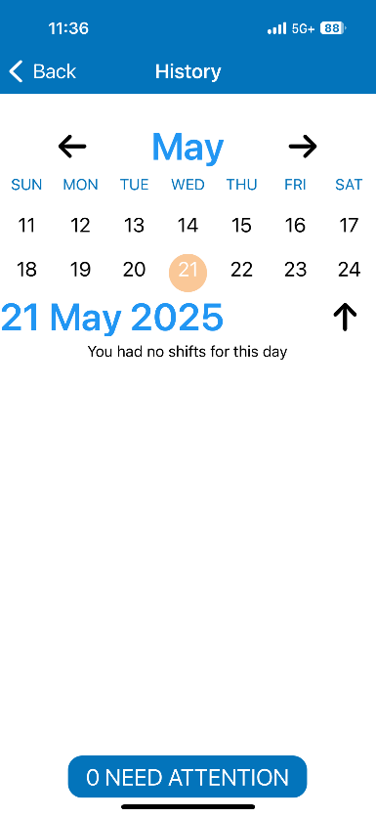
Review your Work History:
- Click on the Work History button.
- Any previous shifts that you have been scheduled for will show on the calendar represented by a colored dot.
- Click on the day of the week to view the assignments connected with that day.

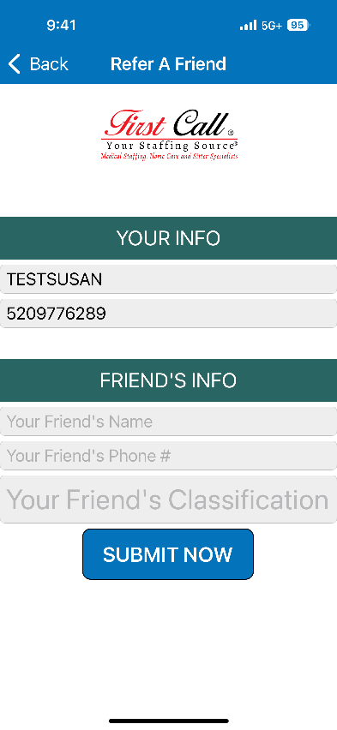
Phone #
Payroll:
- Click the Payroll button.
- Click Start Payroll to be redirected to your Paylocity App.
- Click Yes on the Confirmation pop-up to open the Payroll Mobile Application
- From there, you will need to log into Paylocity as normal.
Refer a Friend:
- If you identify a hardworking healthcare professional, please refer them to First Call!
- Click on the Refer a Friend button.
- Enter in your contact information, as well as your friend’s contact information.
- Click Submit Now.

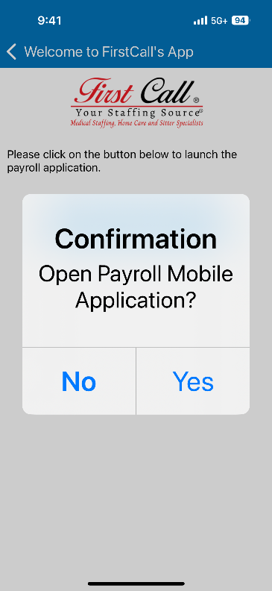

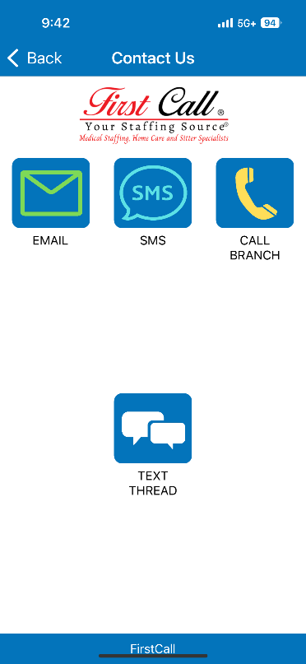
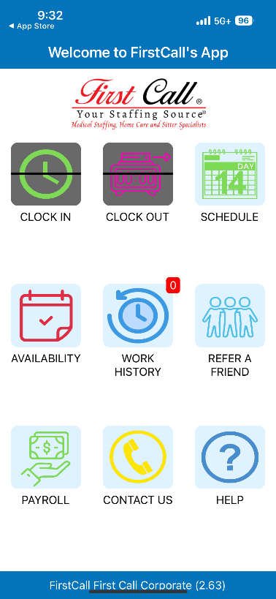Contact us:
- Click the Contact us button.
- You will be given options of Email, SMS (Text), Call, or Text Thread (shows you the previous text conversations).
- Select the method in which you would like to Contact First Call.
Help:
- Click Help.
- This will direct you to the First Call Website.
- From the main page, click on “First Call App” from the navigation bar.
- If the information does not answer your questions, please contact your local First Call branch for additional assistance.

